Press release
26.10.2016

Transnational Project Meeting organized by
Constanta Maritime University, Romania

During 20th and 21st October, 2016, the first transnational project meeting for launching the project “Diversification of seafarers’ employability paths through collaborative development of competences and certification”, Strategic partnership 2016-1-RO01-KA202-024663, took place. The event was hosted by Constanta Maritime University in Constanta, Romania.
Representatives of all four partners participated to the event: Constanta Maritime University (CMU) – Romania, Nikola Yonkov Vaptsarov Naval Academy (NVNA) – Bulgaria, European Association of Career Guidance (EACG) – Cyprus, and Stichting STC-Group (STC-Group), Netherlands.

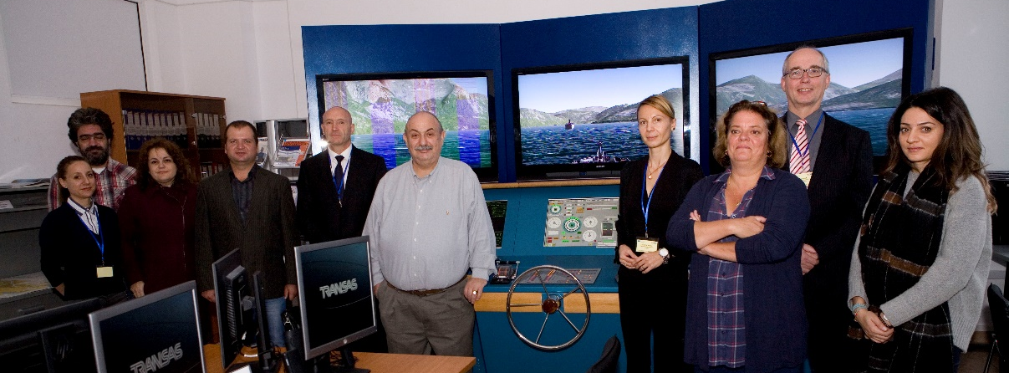
From left to right: Simona Ghiţă (CMU), Mircea Zus (CMU), Alina Boştină (CMU), Todor Koritarov (NVNA), Blagovest Belev (NVNA),
Gregoris Makrides (EACG), Nicoleta Acomi (CMU), Lucie Saxton (STC-Group), Aat Kroek (STC-Group), Elpida Christou (EACG)

The meeting started with presentations of partners’ institutions providing a background of the strategic partnership and emphasizing the value added by the consortium composition. Continuing with discussions about the project implementation, milestones, reporting and financial requirements, the first project meeting created the premises for successfully achieving the main objective of the project „to improve the employability skills and work opportunities for marine workers and to reduce the existing gap between the educational world and labour market”.
Special sessions have been dedicated to debates on project intellectual outputs. The experts discussed and agreed on task distribution for elaboration of the first result, a “marine labour market online survey instrument”. The key benefit of this instrument is collecting feedback that would assist in establishing the skill sets that would be improved during the next stage of the project.
For two years from now, the partner institutions will collaborate for keeping you informed about the progress of activities through the project web-page http://www2.cmu-edu.eu/divsea/. You will find updates and details on project implementation phases supported by EU funded programme ERASMUS+.

Contact
Host: Nicoleta Acomi (Nicoleta.acomi@cmu-edu.eu) şi Mircea Zus (mircea.zus@cmu-edu.eu)
Address: Constanta Maritime University, 104, Mircea cel Bătrân St., 900663, Constanta, Romania

