Press release
09.11.2017

DivSea – the 3rd Transnational Project Meeting organized by
Nikola Yonkov Vaptsarov Naval Academy, Bulgaria

On the 6th and 7th of November, 2017 the third transnational meeting for the implementation of project “Diversification of seafarers’ employability paths through collaborative development of competences and certification”, Strategic partnership 2016-1-RO01-KA202-024663, took place in Varna.
The event was hosted by Nikola Yonkov Vaptsarov Naval Academy, Bulgaria and brought together representatives of all four project partners: Constanta Maritime University (Romania), Nikola Yonkov Vaptsarov Naval Academy (Bulgaria), European Association of Career Guidance (Cyprus) and Stichting STC-Group (Netherlands).

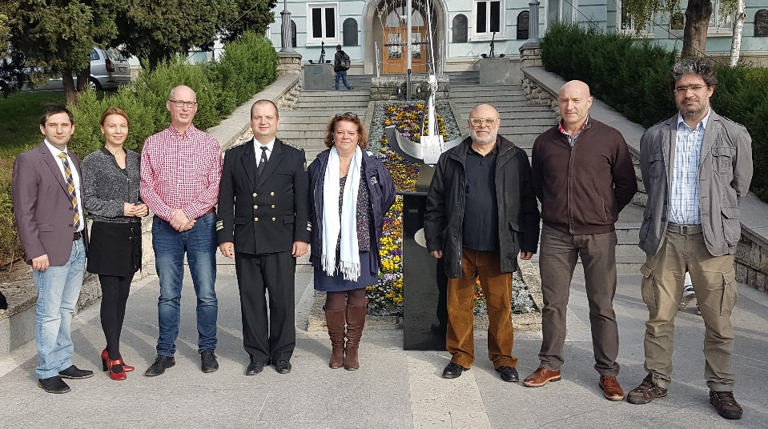
From left to right: Ovidiu Acomi (RO), Nicoleta Acomi (RO), Aat Kroek (NL), Todor Koritarov (BG), Lucie Saxton (NL),
Nikos Stathopoulos (CY), Blagovest Belev (NVNA), Mircea Zus (CMU)

The meeting marked the completion of the first year of implementation and aimed at analyzing the efficiency of the ongoing activities as well as the steps to be taken for increasing the visibility of the results.
During the two days, the participants highlighted the progress in development of teaching and assessment materials for achieving the main objective of the project „to improve the employability skills and work opportunities for marine workers and to reduce the existing gap between the educational world and labour market”. The next period is dedicated to qualitative analysis of the courses and confirmation of the content. The learning materials can be visualized online at http://divsea.cmu-edu.eu/, for the purpose of improving the skills of the marine professionals and not only.
To validate the project outcomes a target group of 25 VET learners will be selected for participation to pilot courses. The courses will be organized by Constanta Maritime University (Romania) and Nikola Yonkov Vaptsarov Naval Academy (Bulgaria).
The partner institutions will collaborate for keeping you informed about the progress of activities through the project web-page http://cmu-edu.eu/divsea/. Here are updates and details on project implementation phases supported by EU funded programme ERASMUS+.
Contact: Nicoleta Acomi (Nicoleta.acomi@cmu-edu.eu) and Mircea Zus (mircea.zus@cmu-edu.eu)

