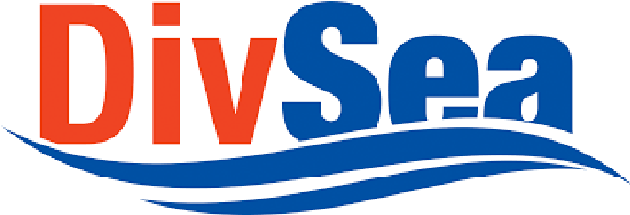
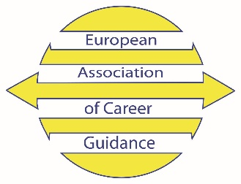
Diversification of seafarers’ employability paths
through development of competences and certification
2016-1-RO01-KA202-024663

INVITATION TO THE INFORMATION EVENT
Dear sir/madam,
You are invited to participate in the information event of the EU Funded Project : Diversification of seafarers’ employability paths through collaborative development of competences and certification where you will have the opportunity to be informed about the projects objectives and results.
When: 18 June, 2018,
Agenda: 18.45 – 19.00 Registration
19:00-20.30 Presentation and discussion (Room AHERA)
20:30 -22.30 Dinner at Hilton (FONTANA restaurant)
(RSVP, collect coupon for dinner during registration)
Where: Hilton Hotel, Nicosia, Cyprus

“Diversification of seafarers’ employability paths through collaborative development of competences and certification” is an Erasmus + Strategic Partnership project implement by four organizations from Romania, Bulgaria, Cyprus and Netherlands.

In the context of the challenging shipping industry environment, the main objective of this EU funded project was “to improve the employability skills and work opportunities for marine workers and to reduce the existing gap between the educational world and labour market by diversification of career paths and skills recognition”.

RSVP - Please reply to the email info@eacg.eu to confirm your participation, no later than 14 June 2018.

European Association of Career Guidance
Partner in the DivSea European Project www.eacg.eu
