¶ (11 pt)
¶ (11 pt)
¶ (11 pt)
¶ (11 pt)
THE TITLE OF THE PAPER (12 pt bold capital letters)
¶ (11 pt)
Name Surname¹, First Name Surname ¹ & First Name Surname ² (11 pt bold)
¶ (11 pt)
¹Constanta Maritime University, Faculty of Naval Electro-Mechanics, 104 Mircea cel Batran Street, 900663, Constanta, Romania, e-mail address:xxxx@yyyy
²¹Constanta “Ovidius” University, Faculty of Natural Sciences, 132, Mamaia Street, 900721, Constanta, Romania, e-mail address:xxxx@yyyy
(10 pt)
¶ (11 pt)
¶ (11 pt)
Abstract (TNR 10pt, bold, italic): Abstract length must be between 150-300 words (10pt). The main sentences of the abstract must present the following aspects: placing the work in context; the purpose of the work; research, methodology; results; conclusions. Please use second-name_first-name-Abstract for correspondence.
Key words (TNR 10pt, bold, italic): The author shall provide up to 5-6 keywords (in alphabetical order) to help identify the major topics of the paper (10 pt).

[SECTION BREAK INSERTED HERE BEFORE 2 COLUMS]

1. INTRODUCTION

The present document contains the instruction for writing the papers published in the Journal of Marine Technology and Environment, Constanta Maritime University. The file has been realized with the use of Microsoft Word, the 2003 version, according to the editing instructions which will be presented as follows. For this reason you can edit your paper in two ways: either you create a new file and then you format it according to the present rules, or you use the commands copy-paste and insert the text of your paper directly into this file.
The papers sent to the journal secretariat for publishing will be edited in DOC format. Editing board will convert the Word files in PDF format.

2. EDITING INSTRUCTIONS

- Do not insert page numbers;
- Do not use bolded characters in the text body;
- Do not use other headers or footers;
- Do not change the styles included in this document.

2.1 Format of the page:

Paper size: A4 (210x297mm).
Margins:
Top: 2 cm
Bottom: 2 cm
Left: 2 cm
Right: 2 cm

2.2 Format of the Columns:

Number of columns: 2
Width and Spacing:
Width: 8,1 cm
Spacing: 0.8 cm

2.3 Format of the Paragraph:

Alignment: Justified
First line Indentation: 0,7cm
Line spacing: single
Please DO NOT use empty lines to arrange the text at the end of a page.
Paper’s length must not exceed 6-10 pages and needs to be even, even if the space on the last page is not entirely used.

2.4 The title and the author of the paper

Use centered, capital and bolded letters for the paper title, Times New Roman 12.
The font for first and last name of the authors is Times New Roman 11.
If there is more one author belonging to the same organization, then its name can be written only once.
The font for the name of the organization is Times New Roman 10.

2.5 Sections and subsections

The titles of sections and subsections will be aligned left and numbered consequently.
For the titles of the sections of the first level (Eg. 1.) use Times New Roman 10, bold, capitals.
In the titles of the sections starting with the second level you will use Times New Roman 10 with italics (Eg. 1.1).
The same for the next level sections (Eg. 1.1.1).

3. TABLES AND FIGURES

Number these consequently, such as Figure 1, Figure 2 or Table 1, Table 2, and so on.
Between the table and its title, as well as after the figure’s title there needs to be a space of 6 points.
Table headings must be placed above tables, and figure specifications placed under the figures.
NOTE: When inserting pictures in the document, make sure their resolution is 600 dpi.
The characters used in the tables and figures are Times New Roman 10.
We will not accept papers that contain obscure figures or figures that do not have all the elements grouped. That is why we ask you that, if you do the figures with the use of the graphical instruments which exist in the package Microsoft Office, to use the command Group.
Tables and figures will be numbered with Arabic numbers as follows:

3.1 Tables

Table 1. The title of the table

text table | text table | text table
text table | text table | text table
text table | text table | text table
text table | text table | text table
text table | text table | text table

3.2 Figures

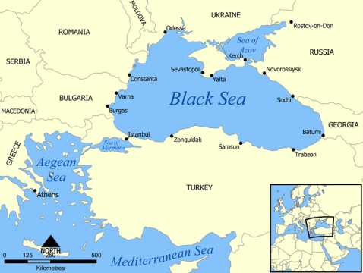

Figure 1 Black Sea boundaries [1]

In exceptional cases, if the width of the tables or figures is bigger then the width of a column, the tables or figures can occupy the entire width of the page, with the condition that they do not exceed the limits of the printing area established by the page format.
[SECTION BREAK INSERTED HERE BEFORE LARGE PICTURE/TABLE ]

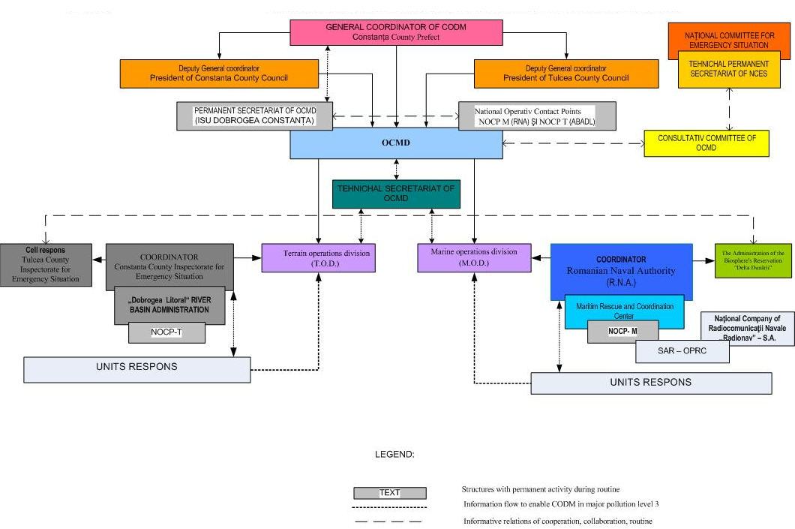

Figure 2 Organization and functioning scheme OCMD [2]
[SECTION BREAK INSERTED HERE BEFORE 2 COLUMS]

4. FORMULAS

The mathematical formulas need to be aligned on the centre of the column and numbered consequently as follows:

(1)

If the size of a formula exceeds the width of a column you can proceed according to the instructions presented for big tables or figures.

5. CONCLUSIONS

Conclusion text

6. ACKNOWLEDGMENTS

You may insert acknowledgements in the paper if necessary before the references section.
7. REFERENCES

It is necessary to insert into the text of paper in the brackets [..] the number of references.
For the visibility of our journal is necessary to mention the titles/authors of papers from the previous numbers of the journal
.
[1] Bârsan E., Carp D., 2003, Economic impact study of Constantza port versus Constantza county, Journal of Coastal Research, Vol.19, no.4, The Coastal Education and Research Foundation, Palm Beach, Fl. US.

[2] Vladut, I., Tanase, C., Operative commandment for marine depollution in context of national system, Brochure „History of accidents in the Black Sea Basin”, project „IUCRISKMAN”, 2014.
[3] http://en.wikipedia.org/wiki/File:Black_Sea_map.
[2] Government Decision no. 893/2006, amending Government Decision nr.1593/2002, approving the National Plan of preparedness, response and cooperation in marine pollution by hydrocarbons;

